**What is the Web?**

* The web consists of clients and servers. The client makes requests, the server responds.
* A client is a user device like a phone, laptop, that is connected to the internet and can access the web, which is a browser like Firefox.
* A server stores webpages, sites, or apps. When a client makes a request from the server, a copy of the webpage gets downloaded on the client.
* **Internet Connection** – This is how you send and receive data on the web.
* **TCP/IP** – Transmission Control Protocol and Internet Protocol, which defines how information travels on the web.
* **DNS** – Domain Name Services, which is an address book for websites. Website names are IP addresses, but humans use things like google.com. The DNS converts names to IP addresses.
* **HTTP**: Hypertext Transfer Protocol – Language the client and servers use.
* **Component Files** – Websites are made up of code files, which contain HTML/CSS/JS, and assets contain things like images, videos, music, etc.

**Process**

1. The user types in the address in the browser. It goes to the DNS to find the real address of the website.
2. The browser, in HTTP, sends a request to the server. This request travels through the internet connection using TCP/IP.
3. If the request is approved, the server sends the necessary files back to the client in small chunks called packets. The reason is that if a full file is transferred and the transfer fails, the whole file needs to be sent again. With this method, if a packet fails, only that packet needs to be sent again. In addition, if there is a congested path certain packets encounter, the remaining packets can be rerouted to a less congested path.
4. The browser gets these packets, and assembles it into a website.

**How the Internet Works**

* You can connect computers together physically or wirelessly (A Network). If you have 10 computers, and you want all of them connected, you need 45 cables to connect each of them (9 + 8 + 7 + 6…). A simpler solution is to connect these 10 computers to another computer, a router, which coordinates messages from one computer in a network to another. This way, you only need 10 cables total.
* You can also connect routers to other routers. In order to connect your network with other networks in the world, you can utilize your telephone infrastructure which already connects to the rest of the world, so you can connect to this. In order to connect to the telephone infrastructure, you need a modem. This turns information from our network to something the telephone network can transfer, and vice versa.
* Now you’re connected to the telephone infrastructure. Now you want to send information from your network, to someone else’s from somewhere in the world. You now connect to an ISP. The ISP has special routers that are linked to other ISPs’ routers. So in essence, your computer sends a message to your router, your router to the modem, the modem to the ISP router(s), and then this ISP router sends it to the other network’s ISP router, and the message is transferred.
* 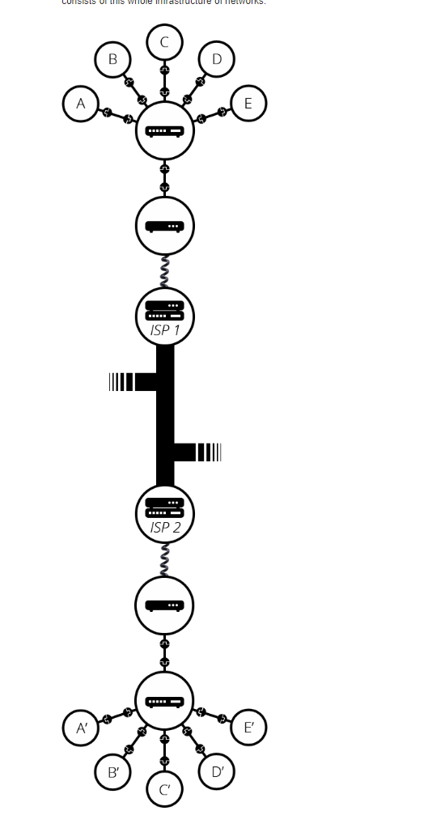

**Web Page**

* A document which can be displayed in a web browser such as Firefox, Google Chrome, Opera, Microsoft Internet Explorer or Edge, or Apple's Safari. These are also often called just "pages."

**Website**

* A collection of web pages which are grouped together and usually connected together in various ways. Often called a "web site" or simply a "site."

**Web Server**

* A computer that hosts a website on the Internet.

**Search Engine**

* A web service that helps you find other web pages, such as Google, Bing, Yahoo, or DuckDuckGo. Search engines are normally accessed through a web browser (e.g. you can perform search engine searches directly in the address bar of Firefox, Chrome, etc.) or through a web page (e.g. [bing.com](https://www.bing.com/) or [duckduckgo.com](https://duckduckgo.com/)).